Dan Blakeman

User Interface Design – D279

**Part I**

Note: Use the “Paradigm Pet Professionals Website” from the Web Links section to view the current website’s content, functionality, and navigation.

A.  Determine the information architecture for the new Paradigm Pet Professionals website based on the attached “Paradigm Pet Professional UI Design Specifications” by doing the following:

1.  Explain the necessary website functionality and micro interactions needed to meet audience and stakeholder needs.

1. The website “Paradigm Pet Professional” states that it offers “resources to help you care for your” animals – which is the company’s mission statement on the Home page. The website does not have any ads or offer anything for sale, so the stakeholders are provided and are giving a free service.
2. There is a navigation bar at the top of the page with ‘Home’, ‘Dogs’, ‘Cats’, and ‘FAQ’. These provide the micro interactions necessary to direct the user to whichever page they would like to go to based on their needs. The page is fairly clean, and the pictures are a consistent size – all of which are user-centered design principles. Some of the links do not work and the navigation bar highlighting does not accurately reflect what page the user is on – so it is not quite as user-friendly or error-free as it could be.

2.  Describe the type of content that will be used for **one** new page based on **one** of the new user personas, including how the elements of the content align directly to the chosen user persona.

1. I chose the Bird Owner user persona. The content aligns with the bird owner persona, if the bird owner is looking for information on how to tell if the owner’s bird is ill – which can happen just as it happens to humans. There is also some general information about bird sizes as well. The Bird Owner web page finally ends with reminding the user to follow up with a veterinarian if the bird owner’s bird has any of the previously described symptoms. The design specifications state that a typical user will be a desktop-owner.
   1. Based off the design specifications, the user would most likely be an older person that is not quite as savvy with cellphones as younger generations. Birds are smaller and typically easier to take care of as they normally reside in a cage. This type of animal would be very appropriate for an older person living alone that cannot potentially get around as much but would still like companionship.

3.  Identify existing content from the website that will be removed or redeveloped and explain how that content fails to meet the proposed audience and stakeholder needs.

A. If I am on the FAQ page, the ‘Home’ navigation button is highlighted, and the user is unable to return to the home page. The underlying design will have to be modified so it works correctly.

4.  Create a visual sitemap to determine the structure and the hierarchy of the site content, including the following:

•  a home page

•  a page for each existing pet page

•  a new page for the new user persona identified in part A2  
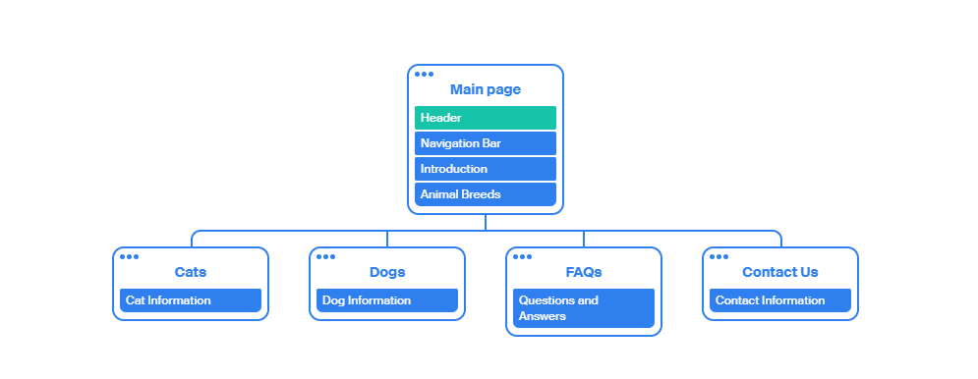

5.  Explain how your information architecture meets audience and stakeholder needs.

1. Audiences’ needs: The audience visiting the website is looking for information on how to take care of domestic pets and small animals - specifically how often to feed the animals, what signs to look for if the animal is sick, and how to groom and vaccinate them. The audience would be anyone that owns a domestic or small animal or a pet store owner looking for additional information that can be provided to customers and assist the owner in what items – such as certain brands or ingredients – should be stocked in the store.

Stakeholders’ needs: The stakeholders – aka the product owners, project managers, and developers, are looking to provide free information to the website’s users as well as links to other nonprofit websites for additional information about the users’ pets. The website potentially could have been created via donations or government grants to lower pet owners’ costs when taking care of their animals.

Per gathercontent.com: “information architecture looks at organisation, labeling, navigation, and search to support usability, functionality, and findability. This organization system supports both users and internal staff (Putkey). Based off this definition, the website is set up very basic website, with only a select few areas to grab the user’s attention. The links/labels are clearly marked based on the species, which makes finding information that the user is looking for easy.

The stakeholders – in this case – have built a website with the intention in mind to grab the user’s attention to those couple of primary and secondary navigational areas, so the user can quickly decide where to navigate to or what to search for. Based on the persona I created, an elderly person could easily get overwhelmed if there was too much information on a particular page, or if the information given was not clear. The navigation bar makes it easy for the user to navigate to another species if they would like or back to the home page. There are only five buttons/links clearly marked, which makes deciding on what page to navigate to, to find the information they are looking for. This is the stakeholders’ intention for the design of this website: small/not too many pages, clearly labeled, and minimalist. With these intentions in mind – as mentioned above, the stakeholders are hoping the visiting user will not be intimidated by the website and feel comfortable navigating to the desired section to find the information needed.

6.  Explain the primary and secondary navigational elements required to support the information architecture.

1. On the home page there are links in two places which navigate to the desired animal breed. The navigation bar – which is consistent across each page of the website (and the primary navigational element) – make navigating the website easily from page-to-page by having that consistency in the navigation bar. Below the navigation bar are links to the same pages with pictures to support the link description, which make it easy to navigate for the stakeholders and audience.
2. Explain how these primary and secondary navigational elements each align with audience and stakeholder needs.

A. One user may just want to use the button links in the navigation bar to get to that species’ page. Those are the primary navigation elements. Another user may want to be more specific and use the ‘Find something…’ search field to search for a specific topic – those are the secondary navigation elements. The layout is not too crowded which can overwhelm some users.

B. The stakeholders – such as the product owner or developers – also want the users to be able to easily navigate their page: There are only 5 links which is simple enough for users to choose from. The search field also stands out on the right side of the screen and because of the way users view the screen (from left to right in an ‘F’ formation), they will see that search field in case they would like to search for something specific.

**Part II**

C.  Create an interactive desktop prototype based on the audience and stakeholder needs using the attached “Paradigm Pet Professional UI Design Specifications” by doing the following:

1.  Include each of the redeveloped “Home,” “Dog Owners,” and “Cat Owners” design prototypes, using content for each corresponding persona from the attached “Paradigm Pet Professionals UI Design Specifications.”

2.  Include **one** new design prototype based on **one** of the new user personas, including the content provided and the format specified in the attached “Paradigm Pet Professionals UI Design Specifications.”

3.  Include a contact form that users can complete to request a virtual consultation with a pet professional that includes all the required fields specified in the attached “Paradigm Pet Professionals UI Design Specifications.”

Note: Your prototype should show the fields that will appear on your contact form, but the contact form does not need to be functional.

4.  Include the primary and secondary navigation elements identified in Part I as well as positional awareness techniques that provide the ability to clearly identify where each page is located within the overall information architecture and that allow users to navigate and interact between all sections of the website.

D.  Provide a .pptx file or compressed .html file of your interactive desktop prototype, including the following:

•  the updated “Home,” “Dog Owners,” and “Cat Owners” design prototypes

•  the new design prototype

•  the virtual consultation form

Note: You can use any tool to create the design prototypes, such as a graphic creation/manipulation software, webpage creation software, presentation software, or another page.

E.  Demonstrate professional communication in the content and presentation of your submission.

Works Cited

Putkey, Theresa. “Content 101: Information Architecture - @GatherContent.” *GatherContent*, 3 Nov. 2021, gathercontent.com/blog/content-101-information-architecture.